**AI LAB - 13**

**Implementation of NLP problem**

**Submitted By**

**Name: VINOTH S**

**Reg No: RA1911030010103**

**Date: 05-04-2022**

**GitHub Link: https://github.com/vk1308**

**AIM:**

To Implement NLP programs.

**LANGUAGE:**

Python

**THEORY:**

* NLP stands for Natural Language Processing, which is a part of Computer Science, Human language, and Artificial Intelligence.
* It is the technology that is used by machines to understand, analyse, manipulate, and interpret human's languages.
* It helps developers to organize knowledge for performing tasks such as translation, automatic summarization, Named Entity Recognition (NER), speech recognition, relationship extraction, and topic segmentation.

**CODE:**

import pandas as pd

import sqlite3

import regex as re

import matplotlib.pyplot as plt

from wordcloud import WordCloud

df = pd.read_csv('emails.csv')

df.head()

print("spam count: " +str(len(df.loc[df.spam==1])))

print("not spam count: " +str(len(df.loc[df.spam==0])))

print(df.shape)

df['spam'] = df['spam'].astype(int)

df = df.drop_duplicates()

print(df.shape)

df = df.reset_index(inplace = False)[['text','spam']]

print(df.shape)

df['spam'].unique()

df.head()

clean_desc = []

for w in range(len(df.text)):

desc = df['text'][w].lower()

*#remove punctuation*

desc = re.sub('[^a-zA-Z]', ' ', desc)

*#remove tags*

desc=re.sub("&lt;/?.*?&gt;"," &lt;&gt; ",desc)

*#remove digits and special chars*

desc=re.sub("(\\d|\\W)+"," ",desc)

clean_desc.append(desc)

*#assign the cleaned descriptions to the data frame*

df['text'] = clean_desc

df = df.reset_index()

df.head(3)

df1 =df.loc[df.spam==0]

df2 =df.loc[df.spam==1]

stop_words = ['is','you','your','and', 'the', 'to', 'from', 'or', 'I', 'for', 'do', 'get', 'not', 'here', 'in', 'im', 'have', 'on', 're', 'new', 'subject']

*#set the word cloud parameters*

wordcloud = WordCloud(width = 800, height = 800, background_color = 'black', stopwords = stop_words, max_words = 1000

, min_font_size = 20).generate(str(df['text']))

*#plot the word cloud*

fig = plt.figure(figsize = (8,8), facecolor = None)

plt.imshow(wordcloud)

plt.axis('off')

plt.show()

wordcloud = WordCloud(width = 800, height = 800, background_color = 'black', stopwords = stop_words, max_words = 1000

, min_font_size = 20).generate(str(df2['text']))

*#plot the word cloud*

fig = plt.figure(figsize = (8,8), facecolor = None)

plt.imshow(wordcloud)

plt.axis('off')

plt.show()

from sklearn.feature_extraction.text import CountVectorizer

from sklearn.model_selection import train_test_split

from sklearn import ensemble

from sklearn.metrics import classification_report, accuracy_score

*#list of sentences*

text = ["the dog is white", "the cat is black", "the cat and the dog are friends"]

*#instantiate the class*

cv = CountVectorizer()

*# tokenize and build vocab*

cv.fit(text)

*# summarize*

print(cv.vocabulary_)

*# encode document*

vector = cv.transform(text)

*# summarize encoded vector*

print(vector.toarray())

from sklearn.feature_extraction.text import CountVectorizer

text_vec = CountVectorizer().fit_transform(df['text'])

from sklearn.model_selection import train_test_split

X_train, X_test, y_train, y_test = train_test_split(text_vec, df['spam'], test_size = 0.45

, random_state = 42, shuffle = True)

from sklearn import ensemble

classifier = ensemble.GradientBoostingClassifier(

n_estimators = 100, *#how many decision trees to build*

learning_rate = 0.5, *#controls rate at which additional decision trees influes overall prediction*

max_depth = 6,

*# min_samples_split = 21,*

*# min_samples_leaf = 19,*

*#max_features = 0.9,*

*#loss = 'huber'*

)

classifier.fit(X_train, y_train)

predictions = classifier.predict(X_test)

print(classification_report(y_test, predictions))

from sklearn.metrics import classification_report,confusion_matrix, accuracy_score

pred = classifier.predict(X_train)

print(classification_report(y_train ,pred ))

print('Confusion Matrix: \n',confusion_matrix(y_train,pred))

print()

print('Accuracy: ', accuracy_score(y_train,pred))

pred = classifier.predict(X_test)

print(classification_report(y_test ,pred ))

print('Confusion Matrix: \n', confusion_matrix(y_test,pred))

print()

print('Accuracy: ', accuracy_score(y_test,pred))

from textblob import TextBlob

*#load the descriptions into textblob*

email_blob = [TextBlob(text) for text in df['text']]

*#add the sentiment metrics to the dataframe*

df['tb_Pol'] = [b.sentiment.polarity for b in email_blob]

df['tb_Subj'] = [b.sentiment.subjectivity for b in email_blob]

*#show dataframe*

df.head(3)

**OUTPUT:**

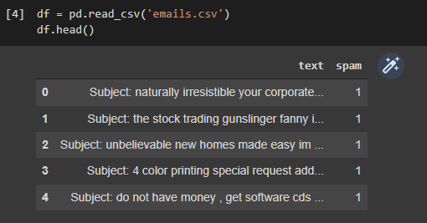

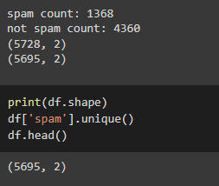

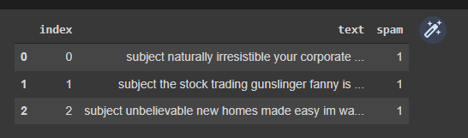

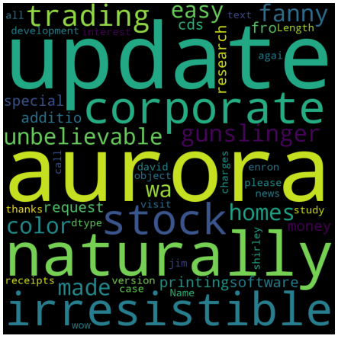

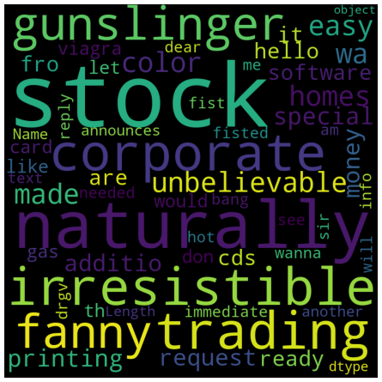

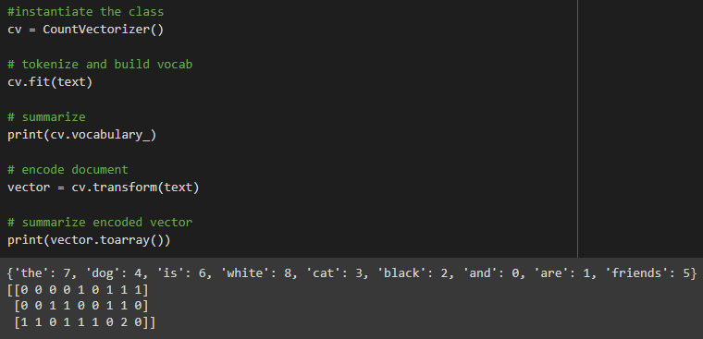

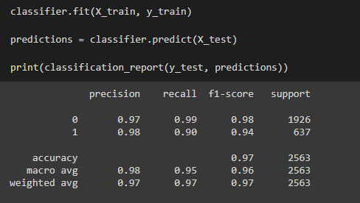

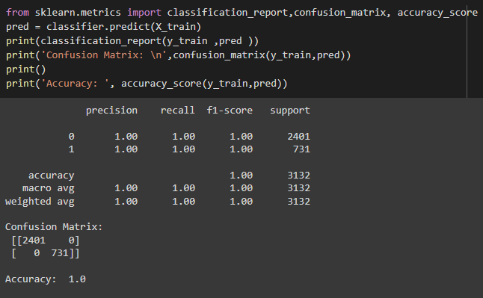

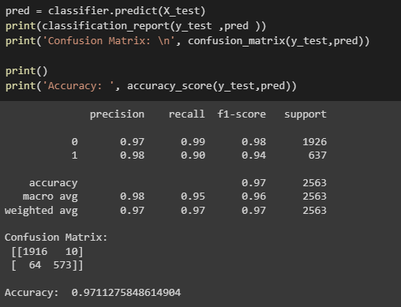

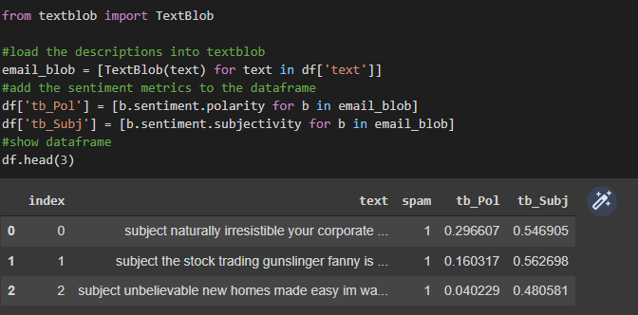

**RESULT:**

Thus, successfully implemented NLP problem.